Directions for Information Technology for the SAT
The SAT is now offered in the Information Technology (IT) Building and no longer meeting at Cone Hall.
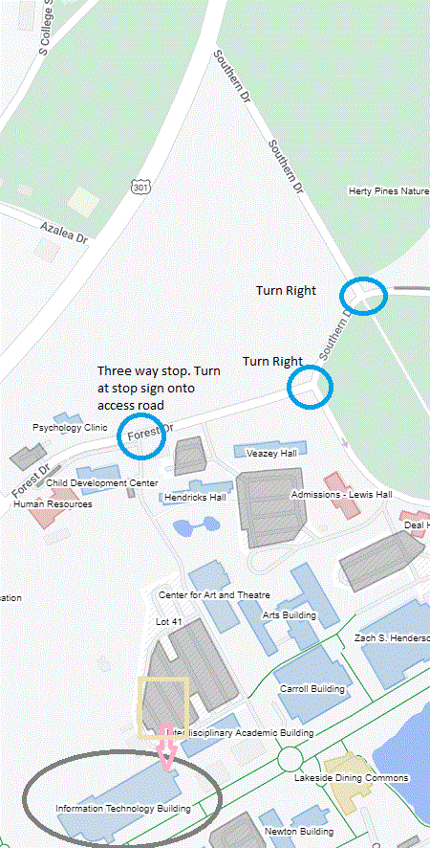
Use the interactive campus map to locate the IT building and parking lot 41. Once you drive into the parking lot the IT building is located at the bottom of the lot. You can park anywhere in the lower lot. Then enter through the glass door with the staircase and walk down the hallway to the lobby to learn your assigned room.
From Cone Hall: Go back to Southern Drive and turn right. Then turn right onto Forest Drive.

Cone Hall
Turn right

